TASK 27.09.2024
Identify the possible Entities and their Attributes from the given scenarios.
Draw ERDs for each of the following scenarios. Draw softboxes, relationship
lines, and labels for each relationship in both directions.

1. HOSPITAL
A hospital consists of several wards, such as Pediatrics, Surgery, Oncology, etc. In each
section, several patients are admitted based on the recommendation of the specialist doctor.
Upon admission, the personal data of the patients are recorded: name, address, telephone, diagnosis. A separate sheet keeps track of the patient's investigations throughout the hospitalization, the results of these investigations, the treatment applied and the results obtained. A patient is assigned to a particular doctor, but a doctor can treat more patients.
Doctors are specialists in various branches of medicine and can supervise patients from more sections. Upon discharge, the patient receives a referral from the specialist doctor and possibly a prescription.
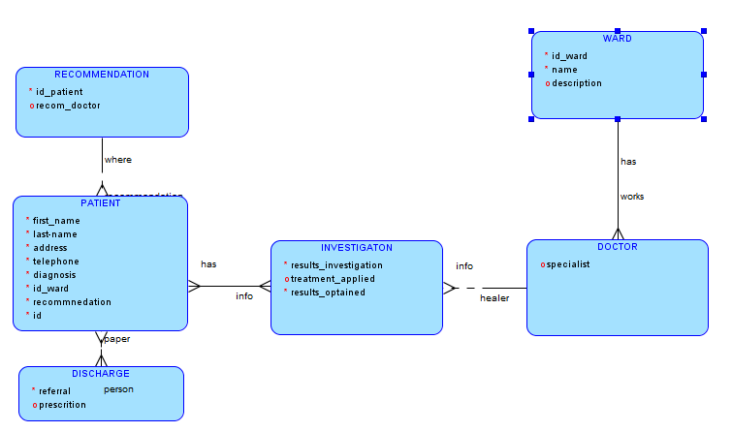

2. CAR RENTAL COMPANY
A car rental company keeps information about the company's cars, the companies with which it has collaboration contracts (for example garages), the rented cars, the company's revenues and data about the company's clients.

For each car we need to know the manufacturer, model, year of manufacture, engine size, fuel type, maximum number of passengers, registration number, rental price, date from which the insurance number is available. All the repairs on the company cars are made by the companies with which they collaborate. Some companies require payment of services immediately after the repair has been made, others accept payment in installments. The clear record of each car, of the rented ones, of those in repair must be kept. It keeps records of the company's revenues and expenses, purchase of new cars, repairs, renting, car insurance fees, etc.

The company has customer information. Customers who collaborate with this company for over 5 years can benefit from a when renting cars. These customers have the opportunity to book a car early. A car can be rented for a period of one day to one year. The rent payment is made in cash or by credit card. Customer information will also be stored:
name, address, telephone number, driving license series and category.
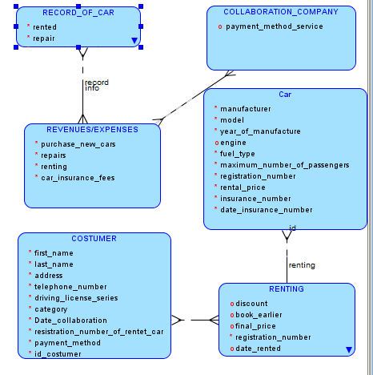
3. A BUS COMPANY
A Country Bus Company owns a number of buses. Each bus is allocated to a particular route, although some routes may have several buses. Each route passes through a number of towns.
One or more drivers are allocated to each stage of a route, which corresponds to a journey through some or all of the towns on a route. Some of the towns have a garage where buses are kept and each of the buses are identified by the registration number and can carry different numbers of passengers, since the vehicles vary in size and can be single or double-decked.
Each route is identified by a route number and information is available on the average number of passengers carried per day for each route. Drivers have an employee number, name, address, and sometimes a telephone number.
